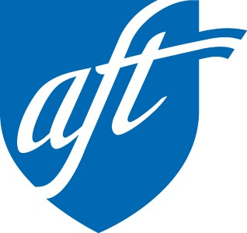
AFT COLORADO
STANDING TOGETHER: MAKING A DIFFERENCE
Committee on Political Education (COPE)
Deduction
925 S. Niagara St., Suite 600, Denver, CO 80224
www.aftcolorado.org • 720-443-8032

FIRST NAME________________________________________ LAST NAME ___________________________________________

BILLING ADDRESS ____________________________________________________________________________________________

BILLING CITY________________________________________ STATE___________________ ZIP_____________________

HOME PHONE_______________________________________ WORK PHONE__________________________________________

MOBILE PHONE ____________________________________ I wish to receive periodic text messages and accept the associated charges.

HOME EMAIL________________________________________ LOCAL ___________________________________________

WORK LOCATION_____________________________________

PAYMENT
Due to the associated fees, we prefer that you sign up for bank draft payment.

MONTHLY COPE AMOUNT $3 $6 $10 NONE $OTHER___________
__________________________________________________________________________________________________________________
BANK DRAFT ****PREFERRED METHOD****
Fill out below or simply attach a voided check.

BANK NAME ___________________________________________________________________________________________________

ROUTING NUMBER ____________________________________ ACCOUNT NUMBER ____________________________

CREDIT/DEBIT CARD: If you choose this method, we will follow up with you to change to bank draft at a later date.

CARD TYPE:  VISA  MC NAME ON CARD__________________________________________________________________________

CARD NUMBER_________________________________________________________ EXP DATE________________ SECURITY CODE___________

I hereby authorize a monthly contribution to the AFT CO COPE (AFT CO COPE) in the amount indicated above. This authorization is signed freely and voluntarily and not out of any fear of reprisal, and I will not be favored nor disadvantaged because I exercise this right. I understand this money will be used to make political contributions by AFT CO COPE. AFT CO COPE may engage in joint fundraising efforts with AFT COPE and/or the AFL-CIO. This voluntary authorization may be revoked at any time by notifying AFT CO COPE in writing of the desire to do so. Contribution or gifts to AFT CO COPE are not deductible as charitable contributions for federal income tax purposes. Contributions cannot be reimbursed or otherwise paid by any other person or entity.

About AFT Colorado COPE: 100% of your contribution will be used in Colorado. The Issues Account is used to advocate for members’ issues such as Public Employees Retirement Association (PERA) security, passing bond and budget elections, as well as supporting our members’ issues on ballot initiatives. Small Donor Account funds are solely used to support candidates who support AFT Colorado’s issues and are endorsed by a panel of members and the AFT Colorado Executive Board. These candidates will include individuals running for boards of education, state legislators and other offices in the state.

SIGNATURE______________________________________________________________________ DATE__________________________________________

