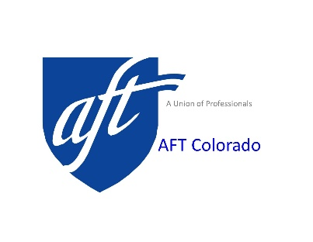
Meyer/Mall Outstanding
Volunteer Award Application

The Meyer/Mall Outstanding Volunteer Award is in memory of two outstanding volunteers. It is the desire of AFT Colorado to honor these members through the creation of the Meyer/Mall Award, to be presented at each convention in recognition of outstanding volunteer service.
Phyllis Meyer was the Secretary/Treasurer of the Denver Federation of Teachers and an officer of AFT Colorado for over 15 years. Phyllis was known for her attention to detail. When we wanted to be sure that a task was accomplished in a timely and professional manner, Phyllis was the one we called on. Her dedication to AFT affiliates and their programs was unprecedented.
Dorothy Mall joined the Denver Federation of Nurses and Healthcare Professionals in the late 1970’s. With others she led a ten year battle that resulted in the first AFT Contract with St. Anthony’s Hospital. In addition to her work in the local, Dorothy also served on the Board of the State Federation for many years. The volunteer efforts of these two members continue to inspire our organization.
Eligible Volunteer: Member, active or retired, of a local in good standing of AFT Colorado who performed significant volunteer service during the prior two calendar years. Possible area of service might include: promoting the benefits of membership, committee work, fund-raising, office work, promoting the union, political action, or assisting in other union activities.

Nomination Procedure:
- The member must be nominated by an AFT Colorado Local. Members-at-Large may be nominated by AFT Colorado.
- The Local must complete the enclosed form and submit it along with a letter of recommendation to AFT Colorado, 925 S. Niagara St., Suite 600, Denver, CO 80224 no later than March 29, 2023 at 11:59 PM. You may also submit via email to: clreiling@aftcolorado.org
- Award applications will be judged by the Convention Committee composed of representatives appointed by the Executive Council of the AFT Colorado. One winner will be selected for the award which will be presented at the Convention of the AFT Colorado on April 29, 2023.

For Further Information email clreiling@aftcolorado.org or call 303-359-9258.

Application – Meyer/Mall Volunteer Award

Section A - Local Union Information

Local Union Name: _____________________________________ Number: ________
Address of Local: _____________________________________________________________
______________________________________________________________________
Phone Number of Officer: _________________________________________________
Local Officer Name: ___________________________________________________________

Section B - Nominee Information

Nominee’s Name: _______________________________________________________
Nominee’s Address: _____________________________________________________
______________________________________________________________________
Nominee’s Local: _______________________________________________________

Section C - Volunteer Information
In addition to this form, please submit a letter of recommendation, not more than two pages in length, detailing:
- the type of work performed and amount of time involved.
- the benefits to the Union from these activities.
- The impact of the volunteer's actions on the organization.

Enclose form and submit along with a letter of recommendation to AFT Colorado, 925 S. Niagara St., Suite 600, Denver, CO 80224, by March 29, 2023 at 11:59 PM. You may also submit via email to: clreiling@aftcolorado.org.

