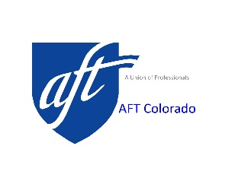
FRIEND OF PUBLIC EDUCATION AWARD

Qualifications
All nominees recommended for the Award should meet the following applicable criteria:
- Be a person or an organization that has made outstanding contributions of statewide or local impact on public education, students and/or teachers in Colorado;
- May not be a practicing educator;
- The contribution should be significant and the nominator(s) should provide specific reasons as to why the nominee should receive the award. The nominator's statement on the nominating form will have substantial bearing on the ultimate selection of the recipient. What was done to justify the nomination should have local or statewide impact.
- The award may be conferred upon a person or an organization in the political, business, or civic community.

Nomination Forms
The nomination forms can be duplicated or retrieved at AFT Colorado’s web-site www.aftcolorado.org to be filled out on your computer.

Selection Process
The AFT Colorado Friend of Public Education Award Selection Committee, which is appointed by the AFT Colorado Executive-Board, will consider all nominations and make its final approval.
Deadline for Submitting Nominations
All nominations must be postmarked or received in the AFT Colorado office on or before 11:59 PM on March 29th, 2023.

Nominations
Any AFT CO affiliate may recommend a candidate by submitting a nomination form via email to clreiling@aftcolorado.org, hand delivering or mailing it to: AFT Colorado, 925 S. Niagara St., Suite 600, Denver, CO 80224
Application – Friend of Public Education

Section A - Local Union Information

Local Union Name: _____________________________________ Number: ________
Address of Local: ____________________________________________________________
___________________________________________________________________________
Phone Number of Officer: _________________________________________________
Local Officer Name: ___________________________________________________________

Section B - Nominee Information

Nominee’s Name: _______________________________________________________
Nominee’s Address: _____________________________________________________
______________________________________________________________________

Section C - Volunteer Information
In addition to this form, please submit a letter of recommendation, not more than two pages in length, detailing:

- the type of contribution to education and amount of time involved.
- the benefits to Education from these activities.
- The impact of the actions locally and statewide.

Enclose form and submit along with a letter of recommendation to AFT Colorado, 925 S. Niagara St., Suite 600, Denver, CO 80224, by March 29, 2023 by 11:59 PM or e-mail to: clreiling@aftcolorado.org.

