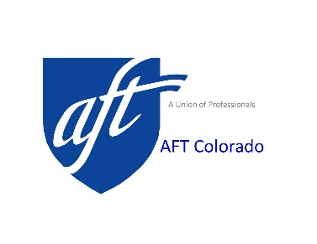
AFT Colorado Officer Nomination Form

Nomination form submitted in accordance with AFT Colorado Constitution, as revised and adopted April 2019, Article 4, Section 2. Election of Officer and Alternates to AFT Convention states, “B. Nominations - Nominations, signed by two (2) AFT Colorado members, shall be received in writing by the AFT Colorado office no later than 30 days prior to the convention. All candidates for office shall be members of the American Federation of Teachers from locals in good standing.” The Executive Board is made up of the President, one eligible Vice President for each local plus an addition of one vice president for each multiple of 500 per-capita paying members in each particular local to AFT Colorado at the next regularly scheduled election and a Secretary/Treasurer. All officer positions are volunteer.
Nominate candidates for President, Secretary/Treasurer, and up to nineteen
Vice President Positions. Each nomination requires two signatures.
President: ______________________________________ Local #: _____________________
Nominators: 1. ________________________ 2. ________________________________

Secretary/Treasurer_________________________________ Local #: ___________________
Nominators: 1. __________________________ 2. _________________________________

Vice President: ____________________________________ Local #: ___________________
Nominators: 1. ___________________________ 2. _________________________________

Vice President: ____________________________________ Local #: ___________________
Nominators: 1. ___________________________ 2. ________________________________

Vice President: ____________________________________ Local #: ___________________
Nominators: 1. ___________________________ 2. ________________________________
By AFT Colorado Constitution, as revised, there may be no more than five (5) officers from any one local. Return this form to the AFT Colorado, 925 S. Niagara St., Suite 600, Denver, CO 80224, by March 29, 2023, by 11:59 PM. We need the original so you cannot scan and email back. See you at Convention April 29, 2023.
Duplicate this form as needed or visit www.aftcolorado.org.

